**Software Requirements Specification**

**for**

**Logistics Management System**

**for Supply Chain**

**Prepared by Nistha Singh, Aditi Goyal, Advay Agrawal**

**Department of CSE, PES University**

**10th September,2023**

***Software Requirements Specification for Logistics Management System***

**Table of Contents**

**1. Introduction..............................................................................................................................1**

1.1 Purpose ............................................................................................................................................ 1 1.2 Document Conventions.................................................................................................................... 1 1.3 Intended Audience and Reading Suggestions.................................................................................. 1 1.4 Product Scope .................................................................................................................................. 1 1.5 References........................................................................................................................................ 1

**2. Overall Description..................................................................................................................2** 2.1 Product Perspective ......................................................................................................................... 2 2.2 Product Functions............................................................................................................................ 2 2.3 User Classes and Characteristics..................................................................................................... 2 2.4 Operating Environment.................................................................................................................... 2 2.5 Design and Implementation Constraints.......................................................................................... 2 2.6 User Documentation ........................................................................................................................ 2 2.7 Assumptions and Dependencies ...................................................................................................... 3

**3. External Interface Requirements...........................................................................................3** 3.1 User Interfaces................................................................................................................................. 3 3.2 Hardware Interfaces......................................................................................................................... 3 3.3 Software Interfaces.......................................................................................................................... 3 3.4 Communications Interfaces ............................................................................................................. 3

**4. System Features........................................................................................................................4** 4.1 System Feature 1.............................................................................................................................. 4 4.2 System Feature 2 (and so on)........................................................................................................... 4

**5. Other Nonfunctional Requirements.......................................................................................4** 5.1 Performance Requirements.............................................................................................................. 4 5.2 Safety Requirements........................................................................................................................ 5 5.3 Security Requirements..................................................................................................................... 5 5.4 Software Quality Attributes............................................................................................................. 5 5.5 Business Rules................................................................................................................................. 5

**6. Other Requirements ................................................................................................................5 Appendix A: Glossary....................................................................................................................5 Appendix B: Analysis Models.......................................................................................................5 Appendix C: To Be Determined List............................................................................................6**

***Software Requirements Specification for Logistics Management System Page 1***

**1. Introduction**

**1.1 Purpose**

*This SRS describes the software functional and nonfunctional requirements for release 1.0 of the Logistics Management System. This document is intended to serve as a contractual basis between the software development team and the stakeholders, ensuring that all parties have a consistent understanding of the system's specifications.*

**1.2 Document Conventions**

*The project team is expected to fulfil every requirement given in this SRS. Unless otherwise noted, all requirements specified here are high priority and committed for release 1.0.*

**1.3 Intended Audience and Reading Suggestions**

*This SRS will be visible to all stakeholders including the project development team, project managers, marketing staff, users, testers, and documentation writers, and the clients.*

**1.4 Product Scope**

*The Logistics Management System (LMS) is conceived as a comprehensive solution tailored for modern businesses to effectively manage and oversee their end-to-end logistics operations. The Logistics Management System is responsible for the following tasks:*

* *Order Fulfilment: Creating new orders for available products, displaying the status of the order, and handling multiple orders simultaneously ensures quick and accurate deliveries.*
* *Inventory Management: Enabling real-time tracking of stock levels, reorder alerts, alert-based stock replenishment and allocating inventory/shipments to orders.*
* *Warehouse management- Monitoring the goods available in the warehouse, which is available for shipment.*
* *Supplier Registration & Management: Facilitate the enrolment of new suppliers who can supply products.*
* *Transportation Management: Facilitating the management and tracking of shipments, route optimization, and carrier selection.*

***Software Requirements Specification for Logistics Management System Page 2***

**1.5 References**

*The Logistics Management System functionalities will be closely related to the following references:*

[*Cin7: Inventory Solutions for Product Sellers*](https://www.cin7.com/)

[*Anvyl: Centralize and Automate Your Supply Chain's First Mile*](https://anvyl.com/)

**2. Overall Description**

**2.1 Product Perspective**

*The Logistics Management System is a software designed to help companies monitor the logistics of the supply chain, for easy and cost-effective manners of supply chain management.*

**2.2 Product Functions**

* *There will be 4 main entities in the current system- Supplier, Customer, Warehouse, and Inventory facility.*
* *The customer can order a product and send a return request at any point of time.*
* *Alarms the inventory manager if stocks in the warehouse are insufficient.*
* *Store and compare purchase and transportation costs from different suppliers and provide the admin with the most cost-effective option.*

**2.3 User Classes and Characteristics**

*Customer- The customer is the entity who will be given a list of available goods from the System. The customer can either order products from the products available in stock, and he can also raise return requests.*

*Inventory Manager- Can view and create orders, check inventory levels, and get alerts if products in the inventory goes below a certain threshold.*

*Warehouse- Storage for available goods. Will let the system know the availability of products, and has access to current orders to be delivered.*

*Suppliers- The suppliers are the entities supplying the products.*

***Software Requirements Specification for Logistics Management System Page 3***

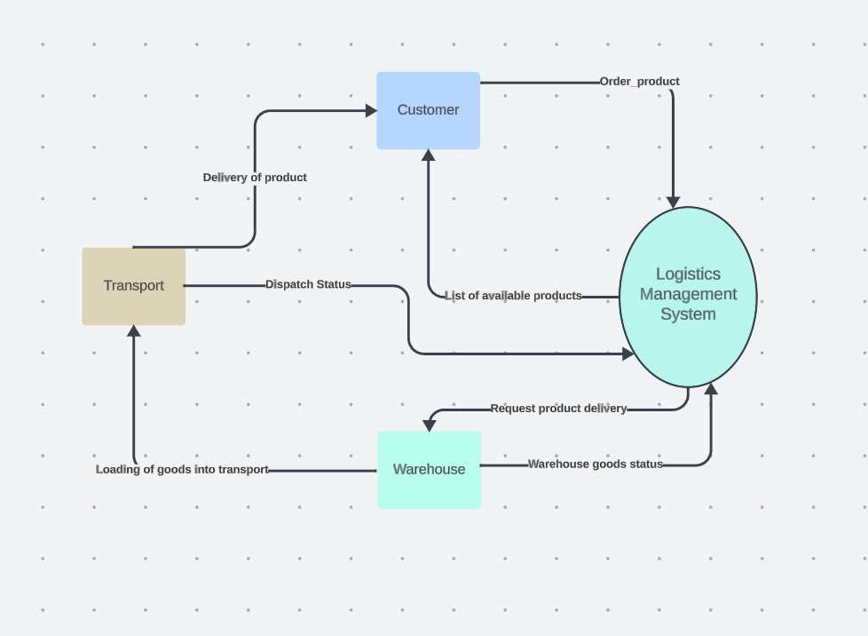

**2.4 Operating Environment**

*The Logistics Management System will be operable in Chromium based browsers, Microsoft Edge, and Safari.*

**2.5 Design and Implementation Constraints**

*CO-1: All HTML code shall conform to the HTML 4.0 standard.*

*CO-2: Scripts shall be written in python, FLASK and SQL Alchemy.*

**2.6 User Documentation**

*UD-1: The system shall provide an online hierarchical and cross-linked help system in HTML that describes and illustrates all system functions.*

***Software Requirements Specification for Logistics Management System Page 4***

**2.7 Assumptions and Dependencies**

*DE-1: The operation of the Logistics Management System depends on the availability of goods to accept payment requests for products ordered with the Logistics Management System.*

*DE-2: The operation of the Logistics Management System depends on changes being made in the Transportation System to update the availability of transport vehicles as Logistics Management System orders are accepted.*

**3. External Interface Requirements**

**3.1 User Interfaces**

*UI-1: The system shall provide a help link from each displayed HTML page to explain how to use that page.*

UI-2: *Responsive design for mobile and tablet access.*

**3.2 Hardware Interfaces**

*No hardware interfaces have been identified.*

**3.3 Software Interfaces**

*SI-1: Signup and Login interfaces*

*SI-1.1: Signup and Login button on the homepage*

*SI-1.2: Different pages for different roles- User, Inventory management and Suppliers*

*SI-2: Product ordering interface*

*SI-2.1: The User or the Inventory manager can create orders.*

*SI-2.2: The User or the Inventory manager can view orders.*

*SI-3: Inventory management interface*

*SI-3.1: The interface allows Inventory managers to view Inventory.*

*SI-3.2: The interface allows warehouse managers to manage current orders to dispatch them.*

*S1-3.3: Orders and Inventory can be viewed via buttons.*

***Software Requirements Specification for Logistics Management System Page 5***

*SI-4: Low inventory alerts*

*SI-4.1: View alerts button leads to alerts regarding low inventory. This is triggered when the inventory goes below a certain threshold.*

*SI-5: Supplier management interface*

*SI-5.1: Suppliers can add to the inventory by supplying products.*

*Sl-5.2: Inventory Managers can manage the suppliers*

**3.4 Communications Interfaces**

*CI-1: The logistics management system will send an email to the customer with the receipt of the order.*

*CI-2: The logistics management system will send a confirmation mail to the customer at the time of delivery.*

**4. System Features**

**4.1 User orders**

4.1.1 Description and Priority

*A user that adds products to their cart and further goes into the delivery stage*

4.1.2 Stimulus/Response Sequences

*Stimulus: User requests order a product*

*Response: System adds the given product into the cart*

*Stimulus: User confirms cart and proceeds to buy.*

*Response: System queries user details for payment and delivery instructions.*

*4.1.3 Functional Requirements*

*REQ-1: User can add or remove the required products into his cart*

*REQ-2: User can issue a return required for previously delivered products*

*REQ-3: User can add only those products which are available in the inventory*

**4.2 Inventory management**

4.2.1 Description and Priority

*The Inventory managers software to monitor goods, track current orders and stock.*

***Software Requirements Specification for Logistics Management System Page 6***

4.2.2 Stimulus/Response Sequences

*Stimulus: Product request arrives.*

*Response: System gets the product ready for dispatch, if available.*

*Stimulus: Low stock of goods in the warehouse.*

*Response: System alerts the warehouse manager by sending him an automated phone call/email.*

*Stimulus: Supplier adds products into the inventory*

*Response: The product should be reflected in the current Inventory.*

*4.2.3 Functional Requirements*

*REQ-1: Orders can be made by the Inventory manager for products.*

*REQ-2: Warehouse manager gets an alert of goods that are low in stock.*

**4. 3 Supplier management interface**

4.3.1 Description and Priority

*Suppliers can add to the inventory by supplying products.*

4.1.2 Stimulus/Response Sequences

*Stimulus: Supplier adds/supplies a product.*

*Response: System updates the status of Inventory to include that product.*

*4.1.3 Functional Requirements*

*REQ-1: Suppliers can add to the inventory by supplying products after being reviewed by the managers*

*REQ-2: Inventory manager can view all supplier details.*

***Software Requirements Specification for Logistics Management System Page 7***

**5. Other Nonfunctional Requirements**

**5.1 Performance Requirements**

*PE-1: All Web pages generated by the system shall be fully downloadable in no more than*

*10 seconds.*

*PE-2: Responses to queries shall take no longer than 7 seconds to load onto the screen after*

*the user submits the query.*

*PE-3: The system shall display confirmation messages to users within 5 seconds after the*

*user submits information to the system.*

**5.2 Safety Requirements**

*No safety requirements can be specified.*

**5.3 Security Requirements**

*SE-2: Users shall be required to log in and they should be redirected to their own pages according to their roles of User, Inventory Manager and Supplier respectively.*

*SE-6: The passwords shall be saved in hashed format.*

**5.4 Software Quality Attributes**

*Availability-1: The Logistics Management System shall be available to users 90% of the time.*

*Robustness-1: If the connection between the user and the system is broken prior to an order being either confirmed or cancelled, the Logistics Management System shall enable the user to rollback and keep the products in cart.*

**5.5 Business Rules**

*No business rules are specified.*

**6. Other Requirements**

*Database requirements: SQL* Alchemy (python library)

*Centralized Database: Google Cloud SQL*

***Software Requirements Specification for Logistics Management System Page 8***

**Appendix A: Glossary**

*SRS (Software Requirements Specification): A document that outlines the functional and nonfunctional requirements of a software system.*

*Logistics: The process of planning, implementing, and controlling the efficient flow and storage of goods, services, and information from the point of origin to the point of consumption.*

*SKU (Stock Keeping Unit): A unique identifier for each distinct product or item in inventory.*

*Last Mile Delivery: The final step in the delivery process, typically from a distribution center to the end customer.*

**Appendix B: Analysis Models**

***E-R diagram of database***

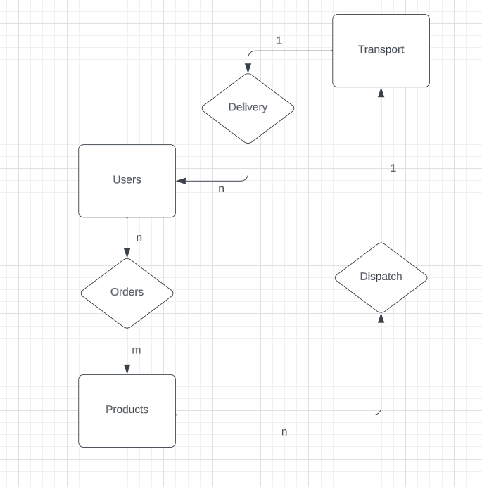

***Software Requirements Specification for Logistics Management System Page 9***

**Appendix C: To Be Determined List**

*Transportation Mode Selection: Determine the optimal transportation modes (e.g., truck, rail, air, sea) for different products and routes.*

*Warehouse Location Strategy: Decide on the locations and capacities of warehouses and distribution centers.*

*Key Performance Indicators (KPIs): Define the KPIs to measure and evaluate the efficiency and effectiveness of logistics operations.*

*Risk Management Plan: Develop a risk management strategy for handling disruptions, delays, and unexpected events in the supply chain.*